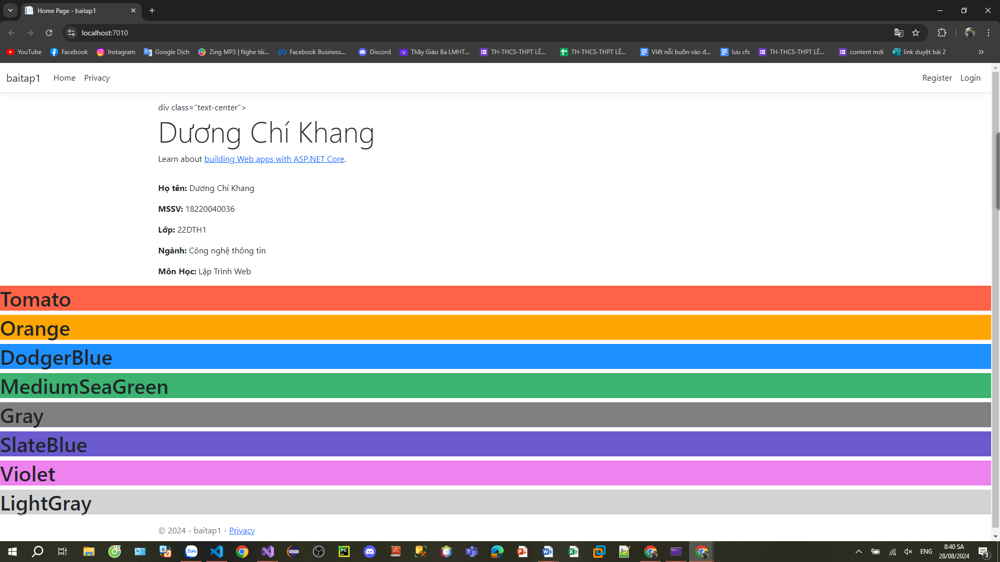

<div class="text-center">

<h1 class="display-4">

Dương Chí Khang </h1>

<p>Learn about <a href="https://learn.microsoft.com/aspnet/core">building Web apps with ASP.NET Core</a>.</p>

</div>

<div class="container info">

<p><b>Họ tên:</b> Dương Chí Khang</p>

<p><b>MSSV:</b> 18220040036</p>

<p><b>Lớp:</b> 22DTH1</p>

<p><b>Ngành:</b> Công nghệ thông tin</p>

<p><b>Môn Học:</b> Lập Trình Web</p>

</div>

<h1 style="background-color:Tomato;">Tomato</h1>

<h1 style="background-color:Orange;">Orange</h1>

<h1 style="background-color:DodgerBlue;">DodgerBlue</h1>

<h1 style="background-color:MediumSeaGreen;">MediumSeaGreen</h1>

<h1 style="background-color:Gray;">Gray</h1>

<h1 style="background-color:SlateBlue;">SlateBlue</h1>

<h1 style="background-color:Violet;">Violet</h1>

<h1 style="background-color:LightGray;">LightGray</h1>